**NUR SYUHAIDAH ISMAIL CB13006**

**2. Learning the different types of locations.**

There are three different types of locations in UPPAAL:

• Normal locations

• Urgent locations

• Committed locations.

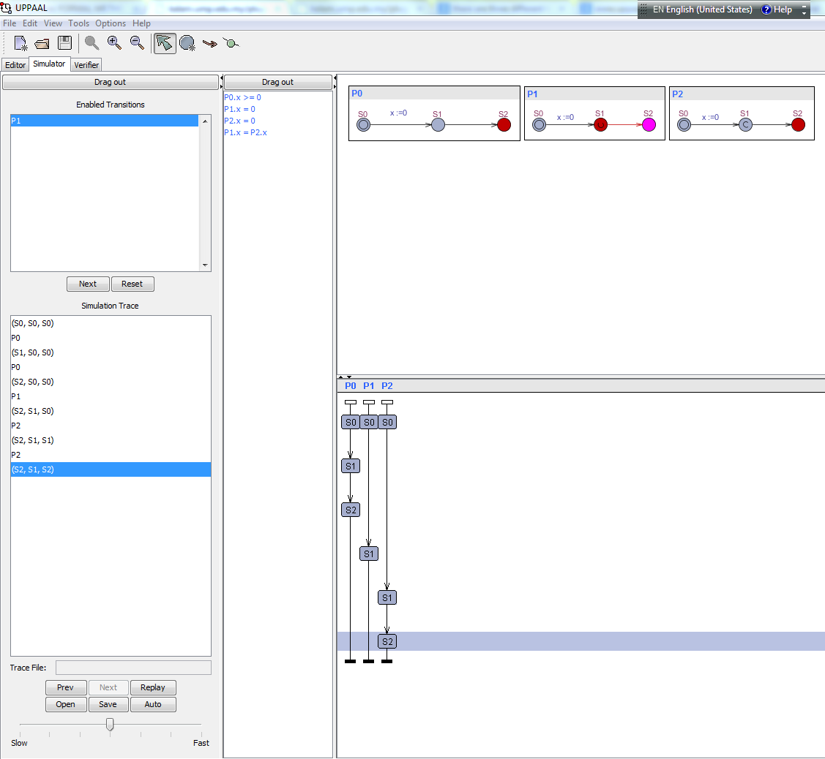

Comments:

1. 3 different locations are running with declare clock x; for each automata (local versus global declarations).
2. The process P0 is start with through the S0 -> S1 – S2, then followed by P1 through the S0->S1
3. The location marked “U” is urgent is placed in P1 and the one marked “C” is committed is placed in P2 because tom try simulator and notice that when in the committed state, the only possible transition is always the one going out of the committed state

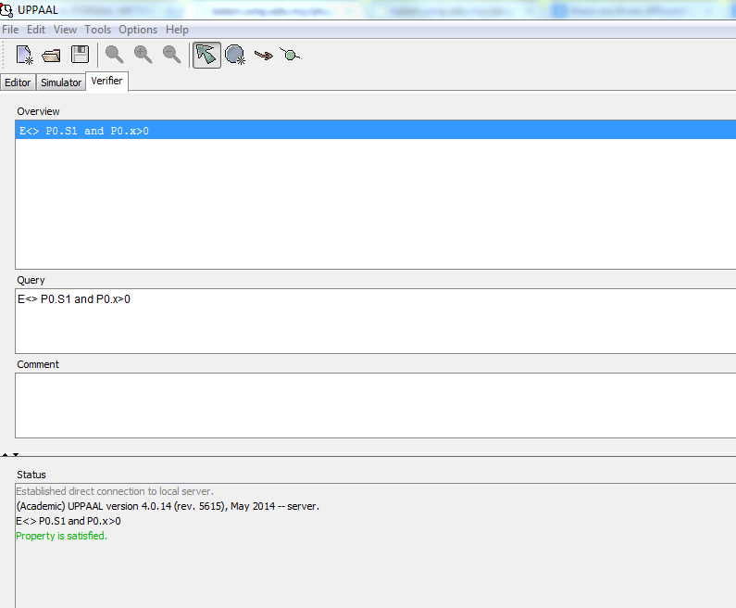

Comments :

1. Verifier Is it possible to wait in S1 of P0 (normal location) E<> P0.S1 and P0.x>0

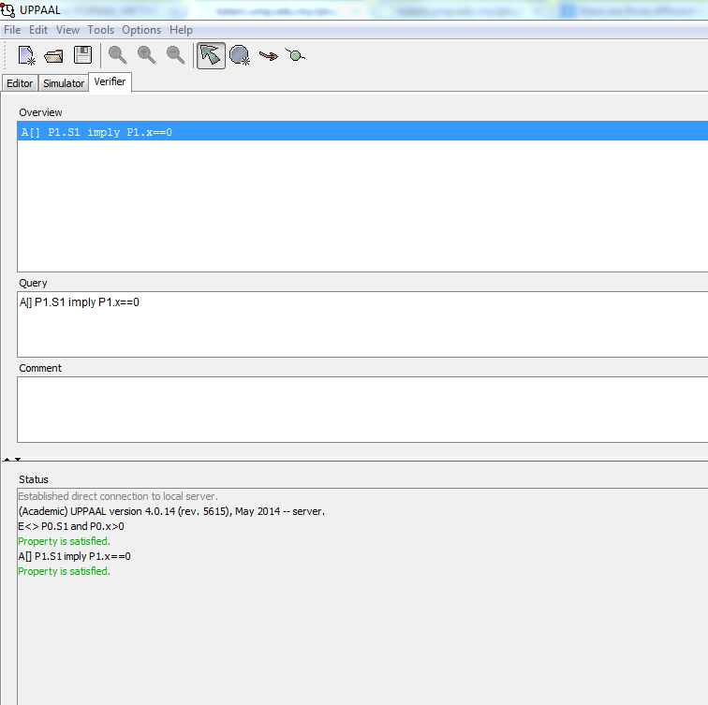

**Comment:**

1. **Verifier It is not possible to wait in S1 of P1 (urgent location)**

**A[] P1.S1 imply P1.x==0 // TRUE**

**A[] P1.S1 imply P1.x>0 // FALSE A[] P1.S1 imply P1.x==0**

1. **The result shows urgent locations are “less strict” variants than committed ones.**

**3. Modelling systems using timed automata**

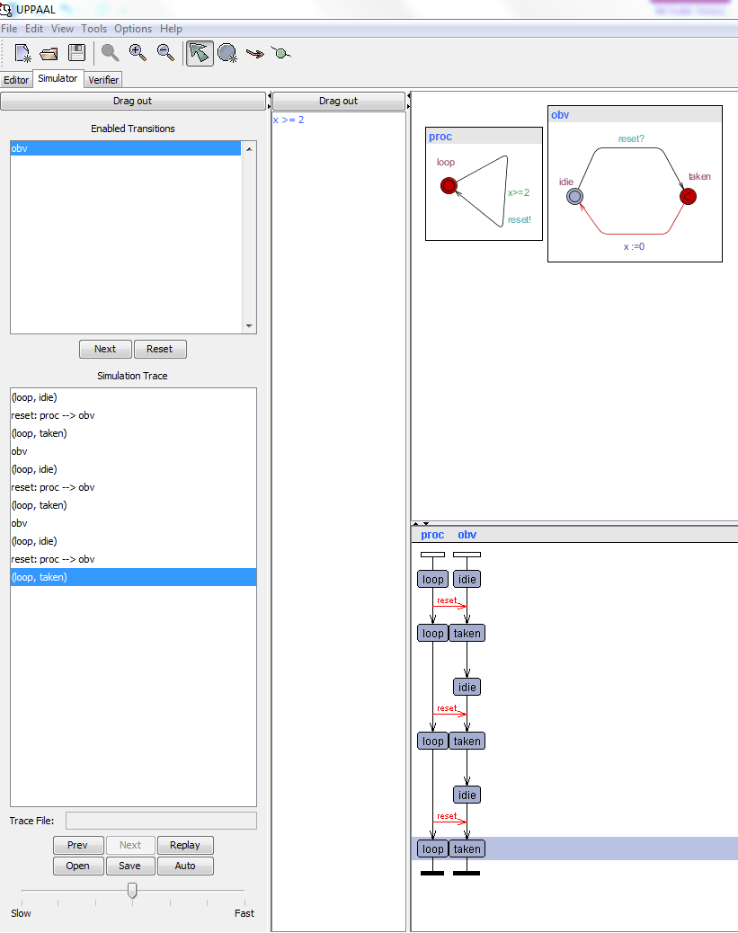

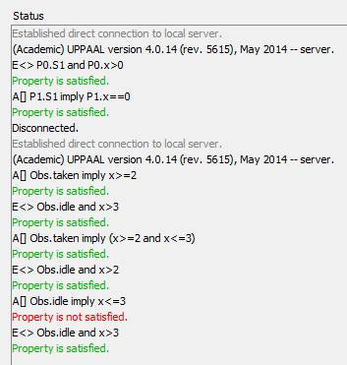

**Comments :**

1. **model, name the automata (templates) Process and Observer are run to define system query**
2. **to exhibit this behavior :**
3. **A[] Obs.taken imply x>=2 is all fall-down of the clock value**
4. **Obs.taken implies that x>=2 Is for all states, being in the location**
5. **E<> Obs.idle and x>3 is waiting period**
6. If you still have time and want to have additional marks develop the model of 4 Vikings, was considered at the lecture 11. Change the model in order it has 5 Vikings. Is it still possible to cross the bridge in 60 min? If so, what should be the time to cross the bridge by this 5 Viking?

